**Assignment No- 14**

**Create an Elastic IP for an instance.**

1. First we will create a instance. Select ubuntu, key pair, select all the check box in security

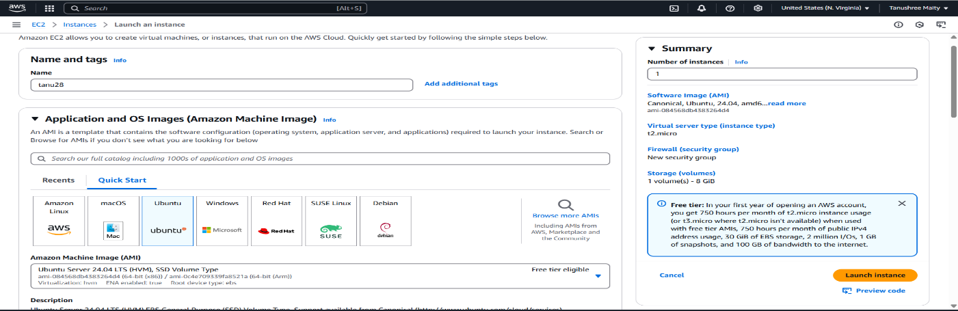

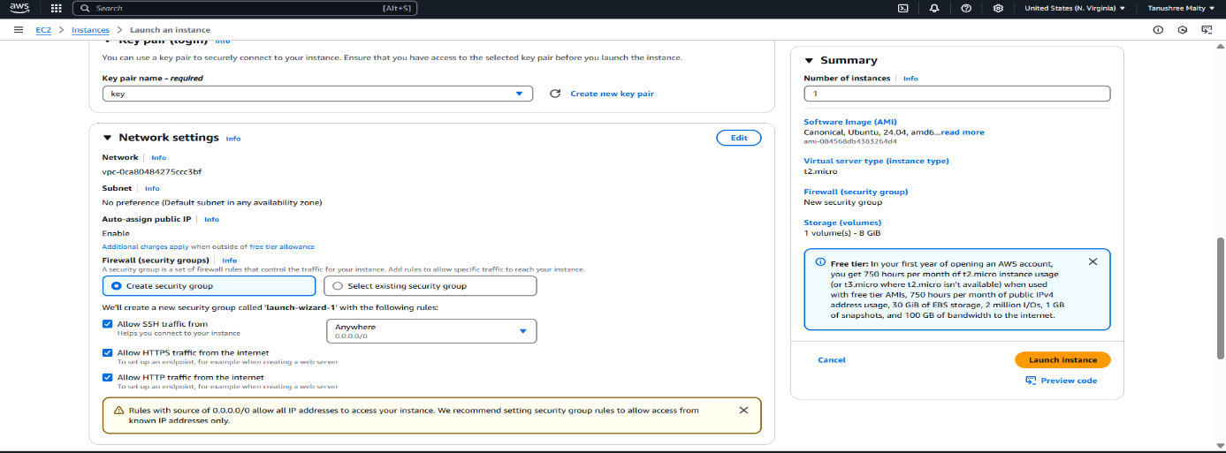

1. Now select instance and stop instance.After some time start instance. Note both pervious and now public IPv4 address. (before stopping-54.145.252.137, after starting-18.212.176.192).

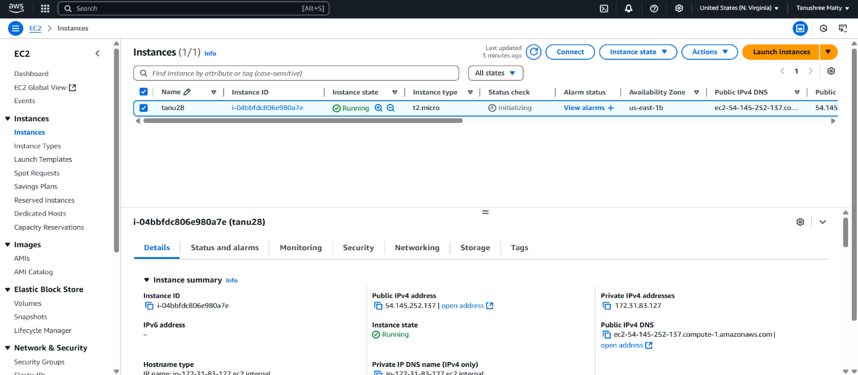

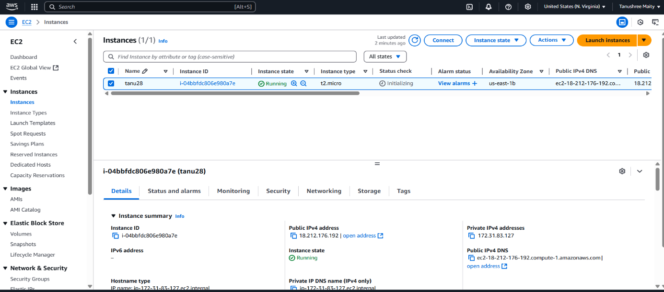

1. Go to Elastic IPs and allocate it.

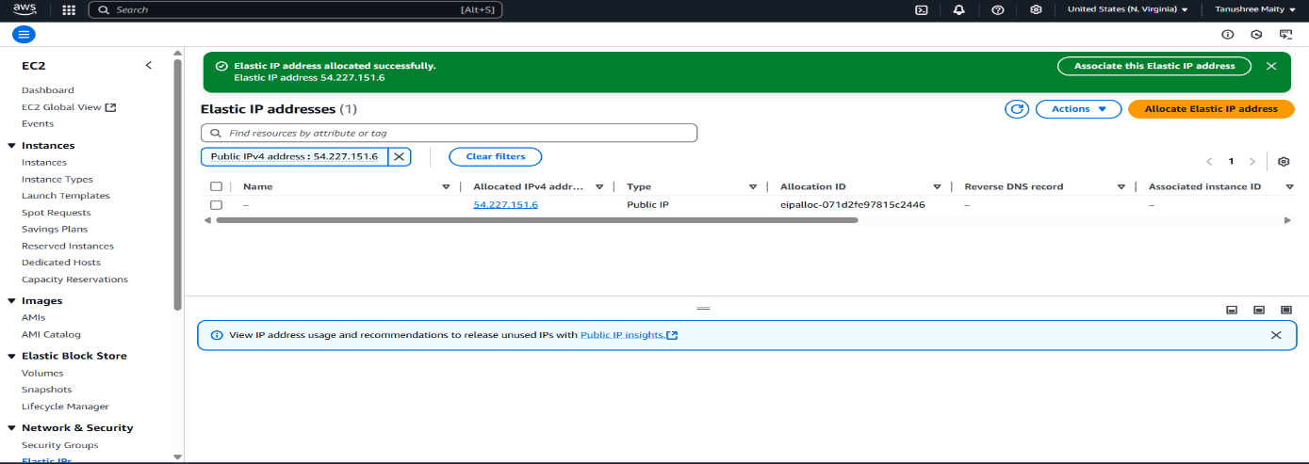

1. Now associate Elastic IP address, select resource type instances.

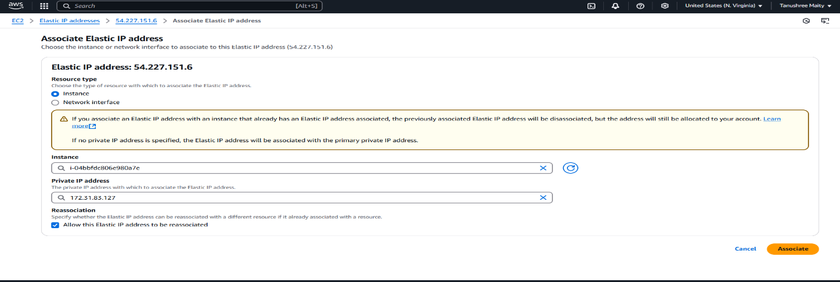

1. Again now stop and start the instance, no IPv4 address will be changed. (before stoping-54.227.151.6, after stopping-54.227.151.6)

